Question week 1

This question is based on the paper `De Reuver, M., Molina, F. J., & Bouwman, H. (2017). Business model innovation design and experimentation in SMEs: drivers and outcomes. Working paper.’

Although business model innovation has been receiving increasing attention in strategic management literature, there are no empirical studies into the effects of business model experimentation on firm performance. Business model experimentation means purposive efforts to try out new business models. In this paper, we examine the antecedents and consequences of business model experimentation using a representative quota sample of European SMEs. We find that business model experimentation has a significant impact on the performance of SMEs. Whether companies conduct business model experimentation depends on several things: their strategic orientation, competition intensity and technology turbulence.

1. Formulate a hypothesis, based on the abstract above. The hypothesis should involve a mediation effect (2 points)

Hypothesis: Firm using business model experimentation can influence the competition to (positively) impact on the performance.

Question week 2

This question is based on the paper `De Reuver, M., Molina, F. J., & Bouwman, H. (2017). Business model innovation design and experimentation in SMEs: drivers and outcomes. Working paper.’

Although business model innovation has been receiving increasing attention in strategic management literature, there are no empirical studies into the effects of business model experimentation on firm performance. Business model experimentation means purposive efforts to try out new business models. In this paper, we examine the antecedents and consequences of business model experimentation using a representative quota sample of European SMEs. We find that business model experimentation has a significant impact on the performance of SMEs. Whether companies conduct business model experimentation depends on several things: their strategic orientation, competition intensity and technology turbulence.

2a. Formulate a questionnaire item for the construct `business model experimentation’. The questionnaire item should have a Likert scale. In your answer, include the wording of the item as well as the answer categories (2 points)

2b. Suggest a way to evaluate the face validity of the questionnaire item you suggested (1 point)

2a. To what extend to you agree with the statement “trying out new business models in your company increase the performance”.

Totally agree, agree, neutral, disagree, totally disagree

2b. Ask experts to judge the questionnaire.

## *Case study design (3 points)*

Q: Robert Yin (2018) mentions four main criticisms on case study research. Mention two of these four criticisms and provide a solution to deal with both of these criticisms (max 150 words).

1. Lack of rigor: use systematic procedure and study protocol.
2. Little basis for generalization: involves multiple case design
3. Take much time: use clear study protocol
4. Too much detail, getting lost in material: use systematic procedures

## *Qualitative analysis / coding (2 points)*

Q: Explain two out of the three main steps to be taken in the qualitative data analysis. Explain each step in 2-3 sentences (max 120 words).

1. Data reduction: select the data that is needed and categorize the data.
2. Data display: present the data
3. Drawing conclusion: through various iterative processes, come up with the conclusion

**Question 1 (total score 3 points)**

Researchers investigated the impact of two personality traits (BIS and BAS) on a person’s susceptibility to Generalized Anxiety (GA). Two (alternative) hypotheses were tested:

*Hypothesis 1*: People high (vs. low) in BIS are more susceptible to Generalized Anxiety (GA).

*Hypothesis 2*: People high (vs. low) in BAS are more susceptible to Generalized Anxiety (GA).

1. On the next page, you find the JASP output of a regression analysis for this study. Do we accept or reject (alternative) *Hypothesis 1*? [open question; **0.5 point**]. Use the JASP regression output to motivate your answer [open question; **1 point**].

We accept the alternative Hypothesis 1 and reject Hypothesis 1.

From the table, it can be seen that p-value<0.001, which if alpha=0.05, then it is significant.

1. Do we accept or reject (alternative) *Hypothesis 2*? [open question; **0.5 point**] Use the JASP regression output to motivate your answer [open question; **1 point**].

We accept Hypothesis 2 and reject the alternative Hypothesis 2.

From the table, it can be seen that p-value=0.105>0.05=alpha, which means it is not significant.

**JASP Regression Output for Question 1**

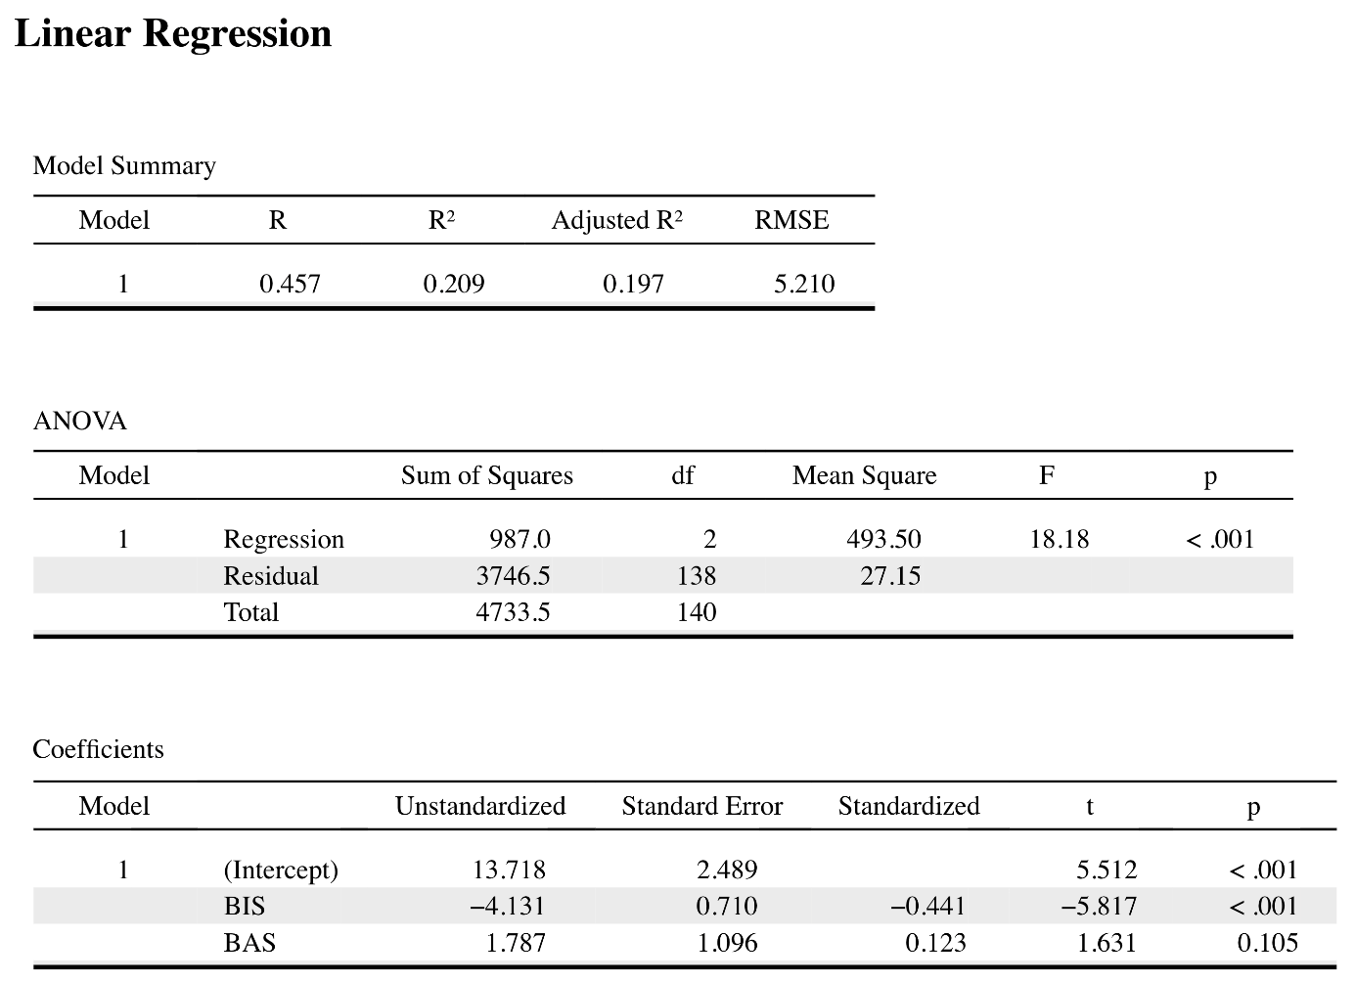

**Question 2 (total of 3 points)**

Below you find a brief description of a prize-winning study by:

Bennett, C. M., Baird, A. A., Miller, M. B., & Wolford, G. L. (2009). Neural Correlates of Interspecies Perspective Taking in the Post-Mortem Atlantic Salmon. *NeuroImage, 47*, S125.

Brief description:

One mature Atlantic Salmon participated in an fMRI study. The salmon was approximately 18 inches long, weighted 3.8 lbs, and was not alive at the time of scanning. The task administered to the salmon involved completing an open-ended mentalizing task. The salmon was shown a series of photographs depicting human individuals in social situations with a specified emotional valence. The salmon was asked to determine what emotion the individual in the photo must have been experiencing. Statistical analysis showed significant activation within the salmon’s brain. The authors did not conclude that the dead salmon was engaging in perspective taking. The researchers used this study to warn researchers to always control for the random noise in fMRI equipment, and to not analyze data without proper calibration.

1. Bougie and Sekaran, in their research methods book, describe seven (7) threats to internal validity in experiments. Which one (1) of those seven threats best applies to what the authors reported on the dead salmon in the fMRI study? Motivate your answer [open question; **1.0 point**]?

Instrumentation effects. fMRI needs control for the noise in equipment, so as the dead salmon’s photographs depicting human individuals in social situations with a specified emotional valence. It fits the instrumentation effects which tells the lack of calibration leads to instrumentation mistake.

1. According to Bougie and Sekaran, which other six (6) threats may interfere with internal validity in experiments? List and briefly describe each of them [open question; **2.0 points**]?

History effects: unexpected events interfere the relationship

Maturation effect: effect due to the long time

Testing effects: post-test

Selection effects: not properly select the random participants

Mortality effect: due to the drop-out

Statistical regression effects: regression to the mean

**Question 3 (total of 3 points)**

A descriptive analysis of the 6 dimensions of the Susceptibility to Persuasion Scale (SPS) yields the following JASP output.

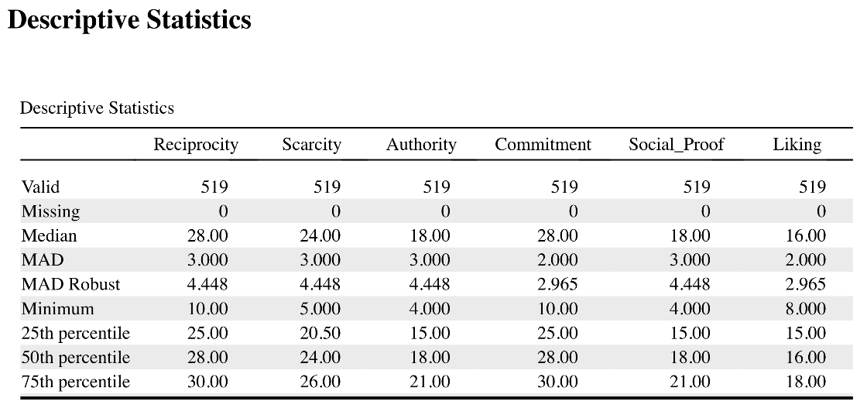

1. Which numerical measures of variation are summarized in this JASP output for the SPS [open question; **1 point**]?
2. Which numerical measures of central tendency are summarized in this JASP output for the SPS [open question; **1 point**]?
3. Theoretically, what can you say about the sensitivity of the median to extreme values [open question; **1 point**]?

**Question 4 (total of 3 points)**

Below you find a correlation analysis of a Technology Acceptance Model, in which all variables (PE, EE, SI, BI) are interval / ratio. The nominal and dichotomous variable Gender is also added to the correlation matrix. This yields the following JASP output.

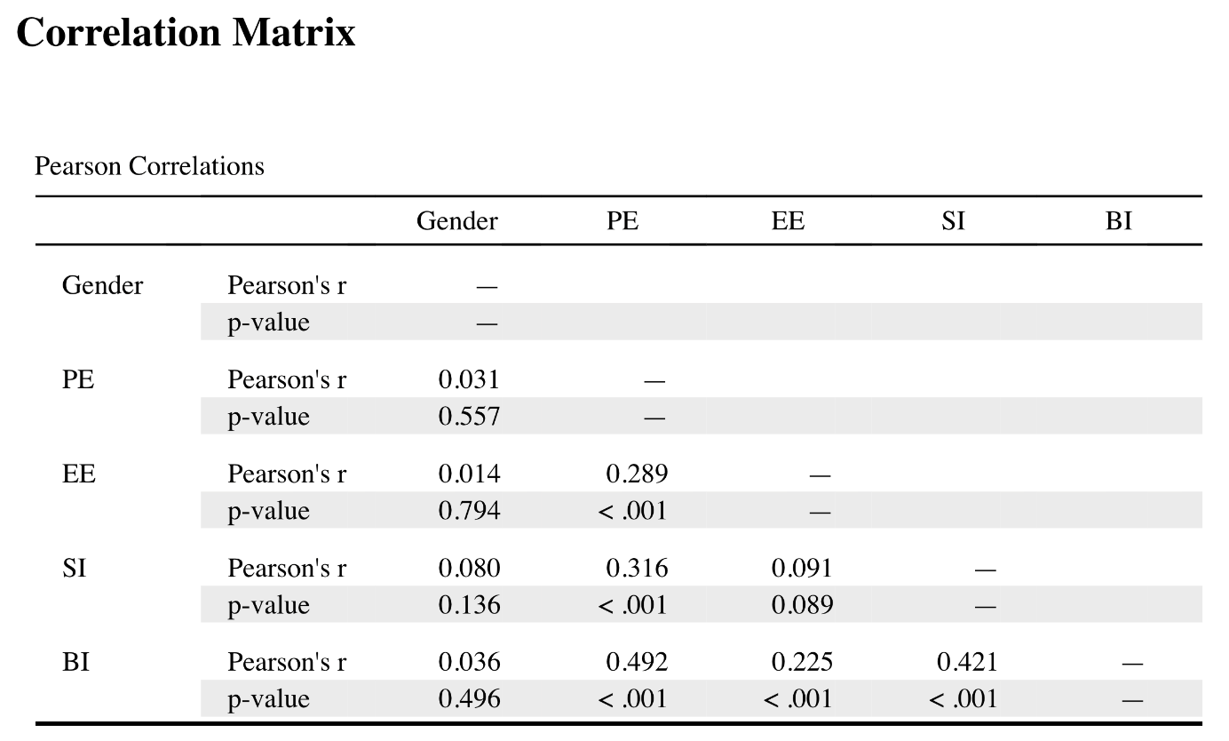

1. How many *moderately strong* bivariate correlations are summarized in the matrix? Identify the pairs [open question; **1.5 points**].
2. It is not appropriate to use the Pearson’s correlation coefficient to calculate correlations between the TAM variables (PE, EE, SI, and BI) and Gender in this output. Explain why not? What would be a better approach [open question; **1.5 points**]?